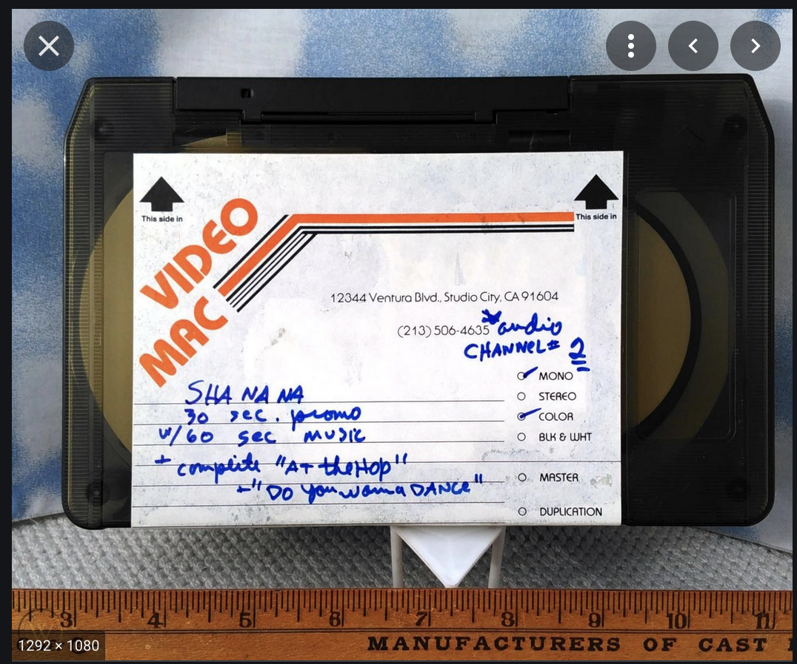

This U-matic promo tape from the Sha Na Na archives was donated to a local university library, which migrated all their U-matics to Digital Betacam tape in the early 2000s. Create a record that includes both tapes.

Extra credit challenge: if the library then digitized the Digital Betacam and created two MP4 access files – one for “At The Hop” and one for “Do You Wanna DANCE” – how would you add those to the record?

